Rios A., University of Castilla-La Mancha, Ciudad Real, Spain
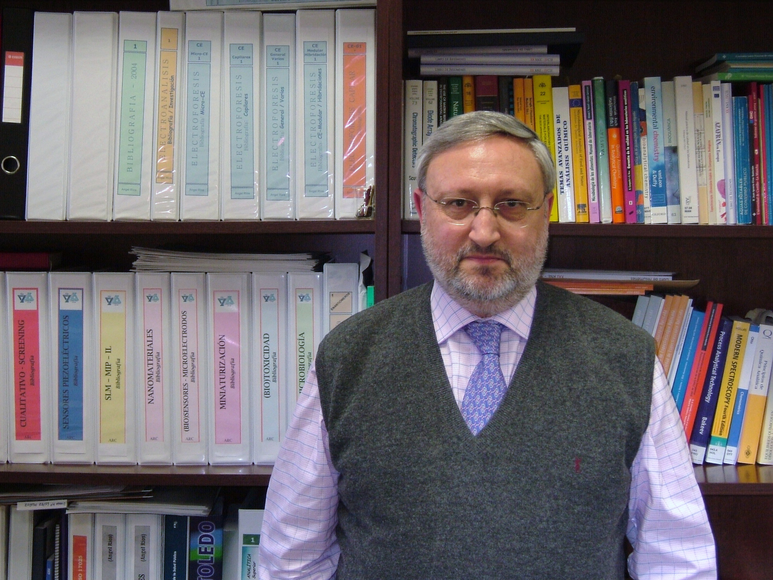

Angel Ríos is Professor of Analytical Chemistry at the University of Castilla – La Mancha, in Ciudad Real (Spain). He was born in 1957 and was graduated in Chemistry at the University of Córdoba, where he obtained the Ph D degree in Chemical Sciences in 1983. His principal fields of interest and activity are the automation and the simplification/miniaturization of analytical processes, in particular the use of continuous flow systems, new developments in sample preparation and non chromatographic continuous separation techniques, Capillary Electrophoresis, integrated analytical systems, sensors for analytical monitoring, as well as the implementation of quality systems in analytical laboratories. Analytical methodologies and developments have been applied in environmental and food fields, mainly.
He is co-author of monographs on “Quality in Analytical Laboratories” (Reverté, 1992; and Síntesis, 2002), “Who is who in Analytical Chemistry (Europe)” (Springer-Verlag, 2002), “Analysis and detection in Capillary Electrophoresis” (Elsevier, 2005), “Miniaturization of Analytical Systems” (Wiley, 2009), and author of ten chapters in national and international books. He has published over 240 scientific articles in international journals and presented about 150 communications in symposia and national/international congresses. He has developed four Spanish patents, he has been the principal investigator in 4 international projects, and 12 national research projects, and has participated in 18 additional projects (8 of them with international scope). He has supervised 17 Doctoral Theses and six more in actual development.
Prof. Ríos has been Secretary of the Regional Group of the Spanish Society for Analytical Chemistry and he belonged to the management board of the Spanish Society of Analytical Chemistry (1993-2005), Society from which he received the prize for Young Researchers in 1986. He was also a member of the directive boards of the Spectrochemical Group of the Royal Society of Chemistry and Groups on Speciation and Education in Analytical Chemistry. He was The President of the Spanish Society of Applied Spectroscopy. He is involved in the Education and Training Group of EURACHEM. At this moment he is the Dean of the Faculty of Chemistry at University of Castilla-La Mancha in Ciudad Real (Spain).
He has participated as an expert in the evaluation of proposals for the European Union within the Third, Fourth, Fifth and Sixth Framework Programmes. He has been invited to present more than 90 lectures in symposia, courses and other scientific events. He has organised 5 courses in Spain on Analytical Quality and has participated as an invited expert in the Regional Course on Quality Management in Analytical Laboratories in Montevideo (Uruguay, April 1998) by the International Atomic Energy Agency and professor in the International Course on Quality Assurance in Analytical Laboratories organised by the AOAC (Buenos Aires, Argentina, June 1998). Within the ARCAL XXVI International Atomic Energy Agency Project Dr Ríos has participated as professor in different National Workshops held in Argentina, Chile and Mexico (July 1998) on topics related to Quality in Analytical Chemistry.

